Bahria University,

Karachi Campus



LAB EXPERIMENT NO.

_______11_______

LIST OF TASKS

|  |  |
| --- | --- |
| TASK NO | OBJECTIVE |
| 1 | **Using Counting semaphore, Create 10 numbers of Threads. Initialize the Semaphore value to 3.** |
| 2 | **Using Binary semaphore make second thread signaled and put first thread in waiting state.**   * + ***First thread perform cube of given number at run time***   + ***Second thread perform sorting of random integer list*** |

Submitted On:

_28-12-2022_

(Date: DD/MM/YY)

**Task # 01: Using Counting semaphore, Create 10 numbers of Threads. Initialize the Semaphore value to 3.**

**Solution:**

#include<iostream>

#include<Windows.h>

using namespace std;

HANDLE hsemaphore;

DWORD threadId;

DWORD WINAPI  MyFun(LPVOID lpParam){

    DWORD dwwaitresult;

    BOOL bcondition=TRUE;

    while(bcondition){

        dwwaitresult=WaitForSingleObject(hsemaphore,INFINITE);

        switch (dwwaitresult)

        {

        case WAIT_OBJECT_0:

            cout<<"\nThread ID: "<<GetCurrentThreadId()<<endl;

            bcondition=false;

            Sleep(2000);

            ReleaseSemaphore(hsemaphore,1,0);

            break;

        case WAIT_TIMEOUT:

            cout<<"Wait is over"<<endl;

            break;

        default:

            break;

        }

    }

}

int main(){

    cout<<"TALHA DAR"<<endl;

    cout<<"\n"<<endl;

    hsemaphore=CreateSemaphore(NULL,3,3,NULL);

    HANDLE hthread[10];

    for(int i=0;i<10;i++){

        hthread[i]=CreateThread(NULL,0,MyFun,NULL,0,&threadId);

    }

    WaitForMultipleObjects(8,hthread,TRUE,INFINITE);

    for(int j=0;j<10;j++){

        CloseHandle(hthread[10]);

    }

    CloseHandle(hsemaphore);

    return 0;

}

Output:

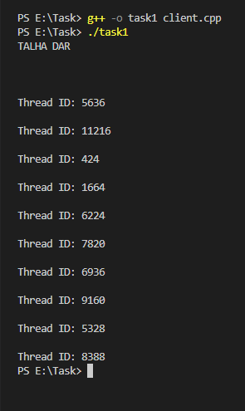

**Task # 02: Using Binary semaphore make second thread signaled and put first thread in waiting state.**

* + **First thread perform cube of given number at run time**
  + **Second thread perform sorting of random integer list**

**Solution:**

#include<iostream>

#include<Windows.h>

#include<math.h>

using namespace std;

HANDLE hTHreadA,hThreadB;

HANDLE hsemaphore;

DWORD threadid1,threadid2;

int a=2,b=1,c;

void bubbleSort(int arr[], int n)

{

    int i, j;

    for (i = 0; i < n - 1; i++)

        for (j = 0; j < n - i - 1; j++)

            if (arr[j] > arr[j + 1])

                swap(arr[j], arr[j + 1]);

}

void ArraySorting(){

     int arr[6]={4,2,7,1,9,8};

    cout<<""<<endl;

    for(int i=0;i<6;i++){

        cout<<arr[i]<<" ";

    }

    cout<<"\nAfter Sorting: "<<endl;

    bubbleSort(arr,6);

    for(int i=0;i<6;i++){

        cout<<arr[i]<<" ";

    }

}

DWORD WINAPI MyFunA(void* lpParam){

    ReleaseSemaphore(hsemaphore,1,0);

    int a=(int )lpParam;

    cout<<"Cube of a number:"<<a*a*a<<endl;

    cout<<endl;

        system("pause");

    return 0;

}

DWORD WINAPI myFunB(LPVOID lpParam){

    WaitForSingleObject(hsemaphore,INFINITE);

    ArraySorting();

    // cout<<endl;

    return 0;

}

int main(){

    cout<<"Enter number of your choice: ";

    int a;

    cin>>a;

    hTHreadA=CreateThread(NULL,0,MyFunA,(void*)a,0,&threadid1);

    hThreadB=CreateThread(NULL,0,myFunB,NULL,0,&threadid2);

    WaitForSingleObject(hTHreadA,INFINITE);

    WaitForSingleObject(hThreadB,INFINITE);

    CloseHandle(hTHreadA);

    CloseHandle(hThreadB);

    return 0;

}

Output:

